Software Requirements Specification

Cancer Model Database

DOCUMENT REVISION HISTORY
Version Number | Date | Description
0.1 | February 22, 2005 | - Initial draft
0.2 | March 03, 2005 | - Updated with team comments
0.3 | September 13, 2005 | - Added search for in-vivo and yeast data
0.4 | September 19, 2005 | - Updated process for registering users
0.5 | January 27, 2009 | - Updated for caMOD 2.5 and submission to VCDE

Background/Summary
Cancer models that recapitulate many aspects of the genesis, progression, and clinical course of human cancers are valuable resources to cancer researchers engaged in a variety of basic, translational, clinical, and epidemiological investigations.

Table of Content
Requirements Specification 1
Cancer Model Database 1
Background/Summary 1
1 Introduction 6
1.1 Overview 6
1.2 Related Documents 6
2 Actors and Goals 7
2.1 Guest User 7
2.2 Registered User 7
2.3 Principle Investigator 7
2.4 Coordinator 7
2.5 Screener 8
2.6 Editor 8
3 Use Cases 9
3.1 caMOD Use Case Model 9
3.2 User Registration with Unknown Principle Investigator (PI) 10
3.2.1 Use Case Model 10
3.2.2 Brief Description 10
3.2.3 Primary Actor 10
3.2.4 Secondary Actors 10
3.2.5 Pre-conditions 10
3.2.6 Basic Flow of Events 10
3.2.7 Post-conditions 11
3.2.8 Alternate Courses 11
3.2.9 Exceptions 11
3.2.10 Supplemental Requirements 11
3.3 User Registration with Known Principle Investigator (PI) 12
3.3.1 Use Case Model 12
3.3.2 Brief Description 12
3.3.3 Primary Actor 12
3.3.4 Secondary Actors 12
3.3.5 Pre-conditions 12
3.3.6 Basic Flow of Events 12
3.3.7 Post-conditions 13
3.3.8 Alternate Courses 13
3.3.9 Exceptions 13
3.3.10 Supplemental Requirements 13
3.4 User Re-registration to create new Principle Investigator (PI) 14
3.4.1 Use Case Model 14
3.4.2 Brief Description 14
3.4.3 Primary Actor 14
3.4.4 Secondary Actors 14
3.4.5 Pre-conditions 14
3.4.6 Basic Flow of Events 14
3.4.7 Post-conditions 15
3.4.8 Alternate Courses 15
3.4.9 Exceptions 15
3.4.10 Supplemental Requirements 15
3.5 Submit Cancer Model 16
3.5.1 Use Case Model 16
3.5.2 Brief Description 16
3.5.3 Primary Actor 16
3.5.4 Secondary Actors 16
3.5.5 Pre-conditions 16
3.5.6 Basic Flow of Events 16
3.5.7 Post-conditions 16
3.5.8 Alternate Courses 17
3.5.9 Exceptions 17
3.5.10 Supplemental Requirements 17
3.6 Edit Cancer Model 19
3.6.1 Use Case Model 19
3.6.2 Brief Description 19
3.6.3 Primary Actor 19
3.6.4 Secondary Actors 19
3.6.5 Pre-conditions 19
3.6.6 Basic Flow of Events 19
3.6.7 Post-conditions 20
3.6.8 Alternate Courses 20
3.6.9 Exceptions 21
3.6.10 Supplemental Requirements 21
3.7 Copy Cancer Model 21
3.7.1 Use Case Model 21
3.7.2 Brief Description 21
3.7.3 Primary Actor 21
3.7.4 Secondary Actors 21
3.7.5 Pre-conditions 21
3.7.6 Basic Flow of Events 21
3.7.7 Post-conditions 22
3.7.8 Alternate Courses 22
3.7.9 Exceptions 22
3.7.10 Supplemental Requirements 22
3.8 Search Cancer Models 22
3.8.1 Use Case Model 22
3.8.2 Brief Description 22
3.8.3 Primary Actor 22
3.8.4 Secondary Actors 22
3.8.5 Pre-conditions 22
3.8.6 Basic Flow of Events 22
3.8.7 Post-conditions 23
3.8.8 Alternate Courses 23
3.8.9 Exceptions 23
3.8.10 Supplemental Requirements 23
3.9 Delete Cancer Model 24
3.9.1 Use Case Model 24
3.9.2 Brief Description 24
3.9.3 Primary Actor 24
3.9.4 Secondary Actors 24
3.9.5 Pre-conditions 24
3.9.6 Basic Flow of Events 24
3.9.7 Post-conditions 24
3.9.8 Alternate Courses 25
3.9.9 Exceptions 26
3.9.10 Supplemental Requirements 26
3.10 Login 26
3.10.1 Brief Description 26
3.10.2 Primary Actor 26
3.10.3 Secondary Actors 26
3.10.4 Pre-conditions 26
3.10.5 Basic Flow of Events 26
3.10.6 Post-conditions 27
3.10.7 Supplemental Requirements 27
3.11 Search in-vivo and yeast data 27
3.11.1 Use Case Model 27
3.11.2 Brief Description 27
3.11.3 Primary Actor 27
3.11.4 Secondary Actors 27
3.11.5 Pre-conditions 27
3.11.6 Basic Flow of Events 27
3.11.7 Post-conditions 28
3.11.8 Alternate Courses 28
3.11.9 Exceptions 28
3.11.10 Supplemental Requirements 29
4 Overall Requirements 29
4.1 Requirements Traceability Matrix 29
4.2 Data Definitions 29
5 Sign Off 31
5.1 Approval 31

Introduction

Overview
The National Cancer Institute (NCI) sponsors numerous projects to develop, analyze, and apply cancer models. The Cancer Models Database (caMOD) is developed as tool by scientists, for scientists and, the goals of the caMOD application are:
- To provide an application and infrastructure supporting cancer models of diverse species to help researchers understand the genesis, progression, and clinical course of human cancer.
- To provide a collaborative repository of internal and publicly available cancer models data and images supporting translational research.
- To develop integrative cancer model components and tools supporting clinical decision making.

The caMOD application is an n-tier web-based application with the following key capabilities:
- Data Submission - Data entries are made by scientists who either generated or worked with the cancer models, or by a curator at the NCI.

- Cancer Model Search - Users can retrieve information about murine models of cancer by querying the database.

- System Function Administration - User registration, review of submitted models, database management.

Related Documents
TBD.

Actors and Goals
The actors associated with the Cancer Models Database (caMOD) application are the users or external systems/entities that interface with the system (the web-based application). Each actor of the portal and the actors associated role(s) are defined below. Figure 2-1 shows the system actors and hierarchies where they exist.
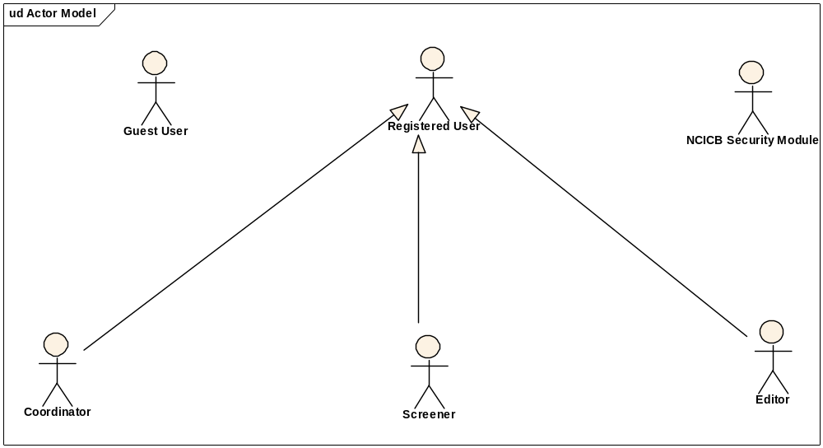
Figure 2-1. caMOD System Actors.

Guest User
The Guest User is any user without a valid system username and password. Guest users may search the cancer models database for public data.

Registered User
The Registered User is any user with a valid system username and password.

Principle Investigator
The Principle Investigator is a caMOD domain object that is specified / created upon registration of a user. A registered user might be a principle investigator, or he may create an associated principle investigator upon registration.

Coordinator
The coordinator is a registered user who appoints screener and editors. The coordinator also grants access privileges and manages the review process. After a model has been entered the coordinator assigns a screener who will check that all required fields have been specified and that the model does not contain junk or grossly inappropriate material. The coordinator will be informed about the decision of the screener by email. If the screener accepted the model the coordinator then assigns the model to an editor, who is a content expert.

Screener
The Screener is a registered user who performs the initial review of submitted models. This review is a quick check that all required fields have been specified and that the model does not contain junk or grossly inappropriate material. The screener also makes a preliminary assessment for clarity, typographic errors and other issues that would make the model less than fully comprehensible. The screening process should be complete within 24 hours. The screener does not contact the submitter about the submission. Any deficiencies found are described in the email to the coordinator. Each email deals with only one submission, so that the emails can be independently routed for vetting.

Editor
The Editor is a registered user who examines a model to see if it satisfies criteria to be made available to the public. The editor also considers any comments, made by the screener, that are passed along in the email from the coordinator. The editor may determine that the model cannot be made acceptable for publication in the database because it requires additional data. If the model has correctable defects, it may be necessary to communicate by email with the submitter to make the model acceptable. Correspondence and telephone contact with the submitters may be conducted through the coordinator. Editors are responsible for maintaining a paper trail or log of email exchanges regarding the models they review. The editor may elect to review a model without assistance. He or she can also request assistance from other subject matter experts. Only the editor has the authority to release the model to the intended audience.

Use Cases
Use cases describe the things actors want the system to do. Use cases are initiated by the system users and together, they typically describe the complete functionality of the system from the user’s point of view. The caMOD use cases are identified and described in the following sections.

caMOD Use Case Model
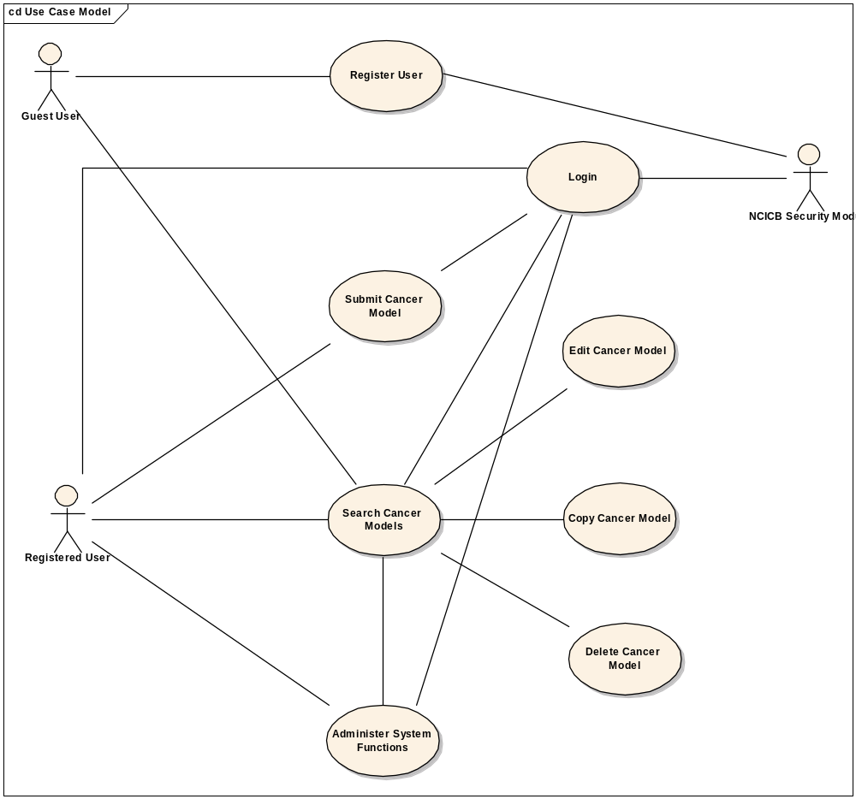
Figure 3-1. caMOD Use Case Diagram

User Registration with Unknown Principle Investigator (PI)

Use Case Model
Reference Figure 3-1.

Brief Description
This Use Case captures the system requirement to allow for a guest user to establish a new system account with an associated username and password, and the creation of a new Principle Investigator object in the caMOD system.

Primary Actor
The Primary Actor in this Use Case is the Guest User.

Secondary Actors
None.

Pre-conditions
The preconditions of the Register User Use Case are identified below. These conditions must be met prior to the use case being performed and they all represent the successful scenario.

No Valid Login
The user does not have a valid system username and password.

PI does not exist
The PI specified does not exist in the caMOD system

Basic Flow of Events
- Submitter goes to the registration page and types in identifying information.
- Submitter indicates that he is not a PI
- The submitter fills in the PI information and hits submit.
- An Email is sent to the caMOD controller. The controller verifies the PI and submitter information and forwards it to the NIH help desk.
- NIH help processes the account request and sends a message back to the caMOD controller.
- Once the new user has been processed, the submitter and the PI objects are created in our database. The PI object is flagged as a PI and the username created from the NIH help desk is associated with the submitter object.
- The e-mail is forwarded back to the registering user
- The submitter logs in, goes to the submission page and is able to select his PI from the PI drop down list.

Post-conditions
- The user is officially registered and has an account with an associated password.
- The user can search public records and submit, edit, and append public cancer model records.
- The PI exists in the caMOD database and shows up in the PI specific drop down list.

Alternate Courses

Alternate Course 1 - Cancellation of Registration Request

Exceptions

The user is already registered. The user will be notified that he/she is already a registered user. The user will be prompted to contact the NIH help desk to change/reset password.

The PI already exists. The caMOD controller determines whether or not the PI data needs to be changed in the caMOD database.

The user already exists as a PI. No PI object is created; instead the PI object is updated w/ the username supplied from the NIH helpdesk.

Supplemental Requirements

The system shall allow the user to register via a web-based graphical user interface.

The system shall have the ability to interface an external system (ie. NCICB Common Security Module), to establish a valid user login.

The system shall require the following data to be provided by the registering user:
  - First Name
  - Last Name
  - Principal Investigator Name (Last Name, First name) and Email Address for PI creation.
  - Email Address

The system shall provide the registering user with the option of providing the following information:
  - Institute
  - Laboratory Name
  - Phone

User Registration with Known Principle Investigator (PI)

Use Case Model
Reference Figure 3-1.

Brief Description
This Use Case captures the system requirement to allow for a guest user to establish a new system account with an associated username and password, and the reuse of an existing Principle Investigator object in the caMOD system.

Primary Actor
The Primary Actor in this Use Case is the Guest User.

Secondary Actors
None.

Pre-conditions
The preconditions of the Register User Use Case are identified below. These conditions must be met prior to the use case being performed and they all represent the successful scenario.

No Valid Login
The user does not have a valid system username and password.

PI exists
The PI specified exists in the caMOD system

Basic Flow of Events
- Submitter goes to the registration page and types in identifying information.
- Submitter indicates that he is not a PI
- Submitter selects a knows PI from the dropdown list and hits submit
- An Email is sent to the caMOD controller. The controller verifies the submitter information and forwards it to the NIH help desk.
- NIH help processes the account request and sends a message back to the caMOD controller.
- Once the new user has been processed, the submitter object is created in our database. The username created from the NIH help desk is associated with the submitter object.
- The e-mail is forwarded back to the registering user.
- The submitter logs in, goes to the submission page and is able to select his PI from the PI drop down list.

Post-conditions
- The user is officially registered and has an account with an associated and password.
- The user can search public records and submit, edit, and append public cancer model records.
- The PI exists in the caMOD database and shows up in PI specific drop down list.

Alternate Courses

Alternate Course 1 - Cancellation of Registration Request

Exceptions

The user is already registered. The user will be notified that he/she is already a registered user. The user will be prompted to contact the NIH help desk to change/reset password.

The user already exists as a PI. No PI object is created; instead the PI object is updated w/ the username supplied from the NIH helpdesk.

Supplemental Requirements

The system shall allow the user to register via a web-based graphical user interface.

The system shall have the ability to interface an external system (ie. NCICB Common Security Module), to establish a valid user login.

The system shall require the following data to be provided by the registering user:
- First Name
- Last Name
- Principal Investigator Name selected from a drop down list.

The system shall provide the registering user with the option of providing the following information:
- Institute
- Laboratory Name
- Phone

User Re-registration to create new Principle Investigator (PI)

Use Case Model
Reference Figure 3-1.

Brief Description
This Use Case captures the system requirement to allow for a registered user to create a new PI object in the caMOD database.

Primary Actor
The Primary Actor in this Use Case is the Guest User.

Secondary Actors
None.

Pre-conditions
The preconditions of the Register User Use Case are identified below. These conditions must be met prior to the use case being performed and they all represent the successful scenario.

Has a Valid Logon
The user has a valid system username and password.

PI does not exist
The PI specified does not exist in the caMOD system.

Basic Flow of Events
- Submitter goes to the registration page and types in identifying information.
- Submitter indicates that he is not a PI
- The submitter fills in the PI information and hits submit. An Email is sent to the caMOD controller. The controller verifies the PI information.
- The PI object is created in our database. The PI object is flagged as a PI.
- The e-mail is forwarded back to the registering user
- The submitter logs in, goes to the submission page and is able to select his PI from the PI drop down list.

Post-conditions
- The PI exists in the caMOD database and shows up in the PI specific drop down list.

Alternate Courses

Alternate Course 1 - Cancellation of Registration Request

Exceptions

The PI already exists. If the PI has an associated username, nothing is done. If the PI does not have an associated username then then the caMOD controller can update the Email information for the PI if different.

Supplemental Requirements

The system shall allow the user to register via a web-based graphical user interface.

The system shall have the ability to interface an external system (ie. NCICB Common Security Module), to establish a valid user login.

The system shall require the following data to be provided by the registering user:
- First Name
- Last Name
- Principal Investigator Name and Email address

The system shall provide the registering user with the option of providing the following information:
- Institute
- Laboratory Name
- Phone

Submit Cancer Model

Use Case Model
Reference Figure 3-1.

Brief Description
The Submit Cancer Model use case captures the process of a user submitting data for a new cancer model. The user is prompted for several pieces of information including a public release date. Once the cancer model is submitted, it will go through the curation process for review and approval.

Primary Actor
The Primary Actor in this Use Case would be classified as a Registered User.

Secondary Actors
None.

Pre-conditions
The preconditions of the Submit Cancer Model Use Case are identified below. These conditions must be met prior to the use case being performed and they all represent the successful scenario.

Valid Login
- The user has successfully is logged in.

Cancer Model Data
- The actor has data to submit new mouse model.

Basic Flow of Events
- The cancer model is entered into the system.
- The user is prompted to enter requested information
- The user enters requested information.
- The user submits the cancel model and the use case ends.

Post-conditions
  - The cancer model is entered into the system.
  - The user declares the data submission to be “complete”
  - Upon submission, the cancer model begins the review process and is awaiting final approval.
  - The cancer model is not accessible by users other than the submitter, principal investigator, coordinator, screener and editor until the model is approved and the confirmed release date has passed.
  - The user is prompted at a future date to confirm the release of the cancer model to the specified domain.

Alternate Courses

Alternate Course 1 – Cancer Model Submission is Cancelled
- The user cancels the cancer model submission.

Exceptions
- The submission session times out. At this point, the user is directed to repeat the login process.
- The user attempts to enter the submission sequence of a new record at any point other than the welcome page. The user is redirected to the welcome page.
- System level failure of the database and/or connection occurs.

Supplemental Requirements

The system shall allow the user to submit Cancer Model data via a web-based graphical user interface.

The system shall only allow authorized uses to submit Cancer Model data.

The system shall allow for the submission of the following types of Cancer Models, such as:
  - Animal Models
    - Mus musculus (Mouse),
    - Homo sapiens (Human)
    - Rattus rattus and Rattus norvegicus (Rat)
    - Meriones unguiculatus (Mongolian Gerbil)
    - Mesocricetus auratus (Hamster)
    - Cavia porcellus (Guinea pig)
    - Bos taurus (Cattle)
    - Canis familiaris (Dog)
    - Capra hircus (Goat)
    - Equus caballus (Horse)
    - Ovis aries, (Sheep)
    - Felis catus (Cat)
    - Sus scrofa (Pig)
    - Danio rerio (Zebrafish)
  - Yeast Models
  - In-vivo Model

The system shall allow the following data types to be entered in association to ALL types of Cancer Models:
  - Model Name
  - Taxon Data
  - Availability Data
  - Principal Investigator Data
  - Publication Data
  - Phenotype Data

The system shall allow for the following data types to entered in association with animal models (see section 3.5.10.5):
  - General Information
  - Genetic Description Data (to include Transgene Data, Induced Mutation Data, Targeted Modification Data)
  - Cell Line Data
  - Therapeutic Approach Data
  - Carcinogenic Intervention Data
  - Microarray Data
  - Model Availability
  - Image Data
  - Histopathology Data
  - Transplantation Data
  - Transient Interference
  - Publication Data

The system shall allow for the following data types to be entered in association with yeast models:
    - Screening Result Data
    - Treatment Data
    - Agent Data
    - Engineered Gene Data
    - Genotype Data
    - Nomenclature Data

The system shall allow the following data types to be entered in associated with in-vivo models:
    - In-vivo Data
    - Tumor Code Data
    - Endpoint Data
    - Agent Data
    - Treatment Data

The system shall allow for the saving of incomplete Cancer Models during submission.

The system shall allow for the submission of Cancer Model data across multiple sessions.

The system shall only allow authorized uses to submit Cancer Model data.

Edit Cancer Model

Use Case Model
Reference Figure 3-1.

Brief Description
The Edit Cancer Model Use Case captures the system requirement to allow registered users to edit an existing cancer model he/she submitted previously.

Primary Actor
The Primary Actor in this Use Case is the Registered User.

Secondary Actors
None.

Pre-conditions
The preconditions of the Edit Cancer Model Use Case are identified below. These conditions must be met prior to the use case being performed and they all represent the successful scenario.

The user has successfully is logged in.

The user has chosen a cancer model to edit.

The user is the submitter or principal investigator of the chosen cancer model.

Basic Flow of Events
  - The application displays a pre-loaded list of models to which the user has access.
  - The user chooses to edit an existing cancer model.
  - The user edits desired information.
  - The user submits edited cancer model and use case ends.

Post-conditions
1. The cancer model has been submitted for review.

Alternate Courses

Alternate Course 1 – Edit Request Canceled
1. The user cancels edit request.

Exceptions

The user attempts to edit a cancer model he/she did not submit. Only the user who submitted the cancer model or the assigned principal investigator may edit the associated data.

Supplemental Requirements

The system shall allow the user to edit Cancer Model data via a web-based graphical user interface.

The system shall only allow authorized users to edit Cancer Model data.

The system shall allow the removal/deletion of portions of a cancel model.

The system shall allow for Cancer Models to be saved once edited.

The system shall not limit the number of times a Cancer Model may be edited.

Copy Cancer Model

Use Case Model
Reference Figure 3-1.

Brief Description
The Copy Cancer Model Use Case captures the system requirement to allow a registered user to duplicate an existing cancer model with the intension of using it as the basis for a new model.

Primary Actor
The Primary Actor in this Use Case is the Registered User.

Secondary Actors
None.

Pre-conditions
The preconditions of the Copy Cancer Model Use Case are identified below. These conditions must be met prior to the use case being performed and they all represent the successful scenario.

The user has successfully logged in.

The user has chosen a cancer model to copy.
3.5.5.3 The user is the submitter.

Basic Flow of Events
- The application displays a pre-loaded list of models to which the user has access.
- The user chooses to copy an existing cancer model.
- The user copies the cancer model.
- The user edits the duplicate cancer model and use case ends.

Post-conditions
- The duplicated cancer model is submitted to for approval.

Alternate Courses

Alternate Course 1 – Copy Request Canceled
1. The user cancels copy request.

Exceptions
TBD.

Supplemental Requirements

The system shall allow the user to copy cancer models via a web-based graphical user interface.

The system shall only allow authorized users the ability to copy Cancer Models.

Search Cancer Models

Use Case Model
Reference Figure 3-1.

Brief Description
The Search Cancer Model Use Case captures the system requirement to allow system users to search the cancer models database.

Primary Actor
- The Primary Actor in this Use Case is the registered user.

Secondary Actors
None.

Pre-conditions
None.

Basic Flow of Events
  - The user chooses to search cancer models.
  - The user is prompted to enter search criteria/criterion.
  - The user enters search parameters and submits request.
  - The user views search results and the use case ends.

Post-conditions
- The actor views the search results.
- The search results contain links to cancer model details
- The search engine is ready for next search request.

Alternate Courses

Alternate Course 1 – Actor Cancels Search Request
1. The user cancels search request before database is queried.

Exceptions

The entered search criteria/criterion yields no records. The user must return to the search criteria to perform another search or exit the system, if complete.

Supplemental Requirements

The system shall provide the user with the ability to search cancer models via a web-based graphical user interface.

The system shall provide a simple search capability.

The system will allow the following criteria to be specified when performing a simple search:
  - Model Descriptor
  - Principal Investigator Name
  - Species
  - Site of Tumor/Lesion

The system shall provide an advanced search capability.

The system will allow the following criteria to be specified when performing an advanced search:
  - Phenotype
  - Publication (PMID)
  - Genetic Description (Models with Transgene, Transgene Name, Models with Targeted Modification, Targeted Modification Gene Name, Genomic Segment Designator)
  - Carcinogenic Agents (Select Carcinogenic Agent Type, Select Carcinogenic Agent Name)
  - Cell Line
  - Therapeutic Approach (Models with Therapeutic Approaches, Compound/Drug)
  - Histopathology (Models with Metastasis)
  - Transient Interference
  - Microarray Data
  - Image Data
  - Tool Strain
  - Data from External Sources

Delete Cancer Model

Use Case Model
Reference Figure 3-1.

Brief Description
The Delete Cancer Model Use Case captures the system requirement to allow a registered user or the assigned principal investigator to delete an existing cancer model. The user cannot delete any previously submitted information unless he/she is the submitter of the original cancer model.

Primary Actor
The Primary Actor in this Use Case is the Registered User.

Secondary Actors
None.

Pre-conditions
The preconditions of the Delete Cancer Model Use Case are identified below. These conditions must be met prior to the use case being performed and they all represent the successful scenario.

The user has successfully logged in.

The user has chosen a cancer model to delete.

The user is the submitter or the assigned principal investigator of the chosen cancer model.

Basic Flow of Events
1. The application displays a pre-loaded list of models to which the user has access.
2. The user selects the cancer model to delete and the use case ends.

Post-conditions
1. The cancer model is marked for deletion and is not longer queryable via the search feature.

Alternate Courses

Alternate Course 1 – Actor Cancels Delete Request
1. The user cancels delete request.

Exceptions

Supplemental Requirements

The system shall provide the user with the ability to delete cancer models via a web-based graphical user interface.

The system shall provide the ability to delete cancer models to user with the appropriate access the model.

The system shall delete all database records selected for deletion.

The system shall not allow deleted records to be recalled.

Login

Brief Description
The Login Use Case captures the system requirement to allow a caMOD user to provide a secure username and password to access the system functions.

Primary Actor
The Primary Actors in this Use Case are:
- Registered User

Secondary Actors
  - NCICB Common Security Module
TDB. (Note: Anticipate the external NCICB Security API/System to be a role player in this process. It would represent an additional system actor and the secondary actor in this use case).

Pre-conditions
The preconditions of the LOGIN Use Case are identified below. These conditions must be met prior to the use case being performed and they all represent the successful scenario. Any exception or error-related use cases will be captured as an appendix to this document.

Valid Username and Password
The caMOD User will have a valid, system-recognized.

Basic Flow of Events
1. The use case starts when an caMOD User selects a function/feature from the caMOD Main Menu.
2. The system prompts the caMOD User for a valid username and password.
3. The caMOD User enters a system-recognized username and password.
4. The system authenticates the user’s login information.
5. The system retrieves the user access privileges for the caMOD User.
6. The use case ends when the caMOD Users privileges are retrieved.

Post-conditions
None.

Supplemental Requirements
None.

Search in-vivo and yeast data

Use Case Model
Reference Figure 3-1.

Brief Description
The Search in-vivo and yeast data Use Case captures the system requirement to allow system users to query the cancer models database for data of the yeast and in-vivo data sets that were imported from NCIs Developmental Therapeutics Program (DTP).

Primary Actor
- The Primary Actor in this Use Case is all users.

Secondary Actors
None.

Pre-conditions
None.

Basic Flow of Events
  - The user chooses to search the cancer models database for in-vivo, yeast, preclinical, and/or clinical trials data (see Figure 3-2)
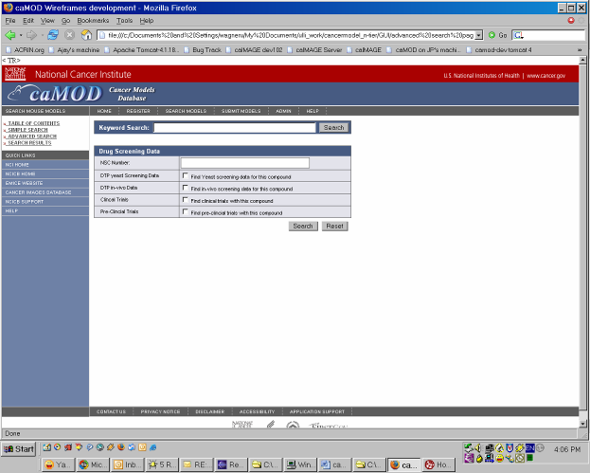
  - The user is prompted to enter search criteria/criterion Search criterion is the NSC number. The user indicates what data set he wishes to query for the NSC number. Data sets to select from are DTP in-vivo, DTP yeast, caBIO clinical trials, and preclinical trials.
  - The user enters search parameters and submits request.
  - The user views summary search results page and if necessary the detail pages and the use case ends.

Post-conditions
- The actor views the search results. (Figure 3-3)
- The search results contain links to in-vivo detail pages
- The search engine is ready for next search request.

Alternate Courses

Alternate Course 1 – Actor Cancels Search Request
1. The user cancels search request before database is queried.

Exceptions

The entered search criteria/criterion yields no records for one, many or all of the four data categories (DTP in-vivo, DTP yeast, caBIO clinical trials, and preclinical trials). The user is being informed that no data are available for a specific category and is must return to the search criteria screen to enter new criteria or exit the system, if complete.

Supplemental Requirements

The system shall provide the user with the ability to search cancer models via a web-based graphical user interface.

The system shall provide a search capability to query for DTP in-vivo, DTP yeast, caBIO clinical trials, and preclinical trials.

Overall Requirements

Requirements Traceability Matrix
Use Case/Supplemental Requirement # | Description | V&V Method | Expected Date of Completion | Date Completed

Data Definitions
TBD

Sign Off

Approval

Workspace General Contractor Rep Print Name Date
Architecture Workspace Rep Print Name Date
VCDE Workspace Rep Print Name Date
Workspace Working Group Rep Print Name Date
NCICB Rep Print Name Date

